***Computer Organization***

**Lab 6 Report**

***Names:***

**عبد الرحمن إسماعيل محمد حسن (22010866)**

**نور الدين اكرم السيد كامل سيف (22011309)**

**Introduction**

This project demonstrates the use of an LED and a potentiometer to simulate an adjustable brightness desk lighting system.

**Implementation Setup**

* Arduino UNO microcontroller board.
* One red LED.
* One resistor (1 kΩ) to limit current to the LED.
* Potentiometer (50 kΩ) to provide variable voltage input to the LED.
* Breadboard for building the circuit.
* Jumper wires for circuit connections.
* Arduino IDE for programming the microcontroller.

**Implementation Details**

* The Arduino continuously reads the analog input from the potentiometer.
* Since the “analogWrite()” function limits written values to 255, the Arduino then maps the read value that ranges between 0 and 1023 to a value that ranges between 0 to 255,.
* The new mapped value is then written to the LED pin with “analogWrite()”.

**Circuit Layout Diagram**

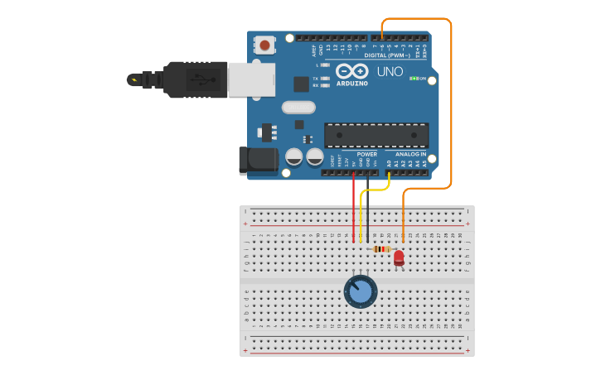

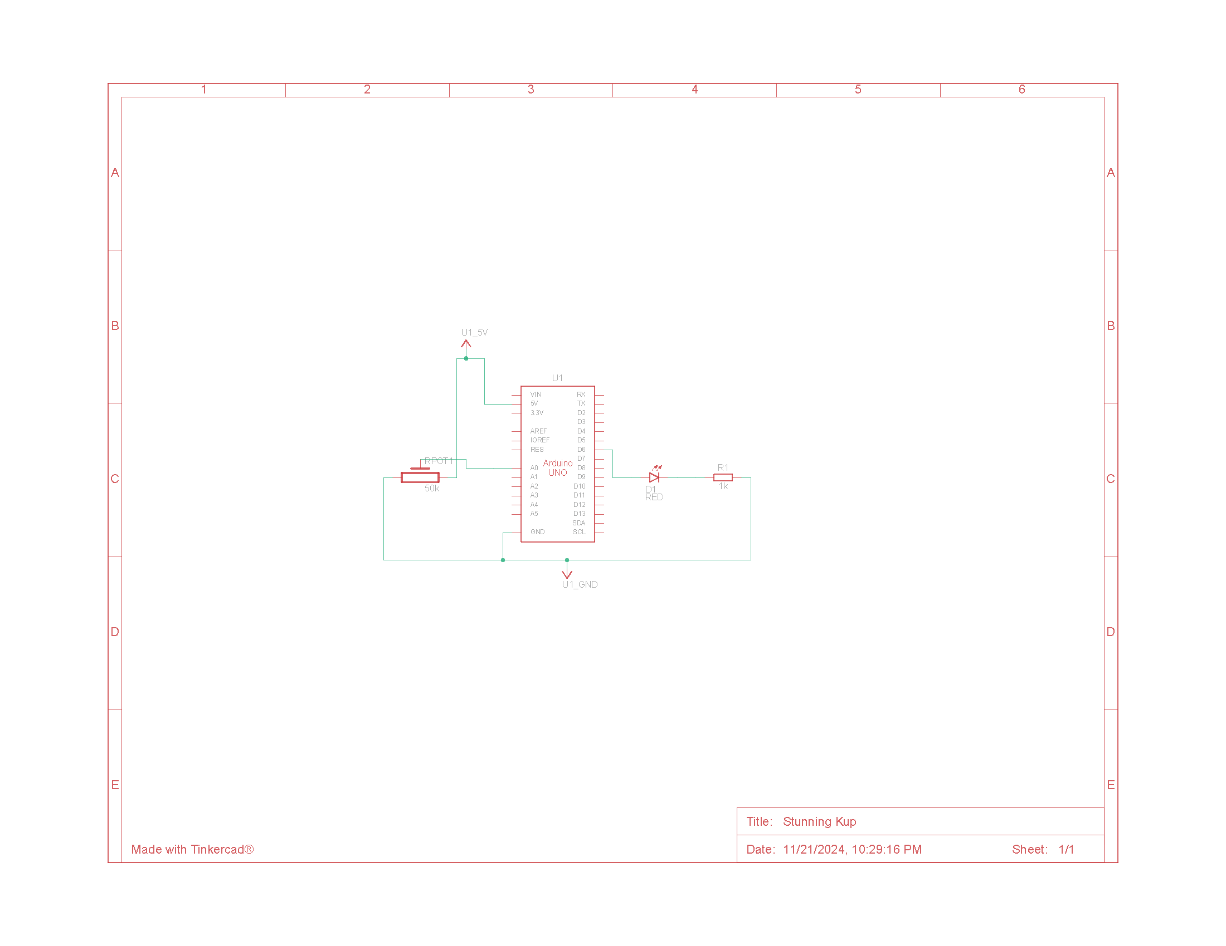**Circuit Schematic Diagram**